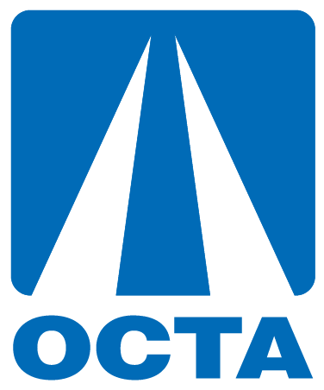
Citizens Advisory Committee (CAC) Recruitment
Social Media Tool Kit
Introduction
The Citizens Advisory Committee (CAC) actively participates in helping examine traffic solutions, providing input to the Orange County Transportation Authority’s (OCTA) transportation studies and communicating with their constituencies. During the year, committee members are asked to participate in roundtable discussions and hear special presentations on various transportation projects, programs, and services.
Committee members are responsible for identifying opportunities for community input, recommending methods for obtaining public opinion, serving as liaisons between the public and OCTA, as well as commenting on significant transportation issues and suggesting possible solutions. OCTA’s Board of Directors is currently seeking qualified applicants for the CAC.
This social media tool kit provides copy-ready content as well as graphics to promote the recruitment of the CAC. The kit provides content so that you may pick and choose text that best resonates with your constituents and post it onto any of your social media platforms. Please consider tagging @goOCTA in your social media posts so that we can easily track information sharing.
Thank you for your help on sharing OCTA’s position openings on the Citizens Advisory Committee.
Social Media Posts:
Twitter
Text: The Orange County Transportation Authority (OCTA) is on the lookout for qualified volunteers to serve on the Citizens Advisory Committee. Applications are due May 2nd! [Link: octa.net/cac]
Facebook
Text: Would you like to provide input on transportation in your community? The Orange County Transportation Authority (OCTA) is seeking those who enjoy helping examine traffic solutions and providing input to transportation studies and outreach activities to become a member of the Citizens Advisory Committee (CAC). For more information, visit octa.net/cac.

Blog/Newsletter/Website
OCTA Seeks Volunteers to Serve on Citizens Advisory Committee

Are you interested in the transportation needs of Orange County? If so, we need your help. The Citizens Advisory Committee (CAC) has openings and we’re recruiting new members. Applications for this OCTA Board-appointed committee are due May 2, 2021.
CAC members provide input on a broad spectrum of transportation projects, studies, and outreach activities. During their two-year terms, they identify opportunities for community input, recommend methods for obtaining public feedback on specific transportation issues, serve as liaisons between the public and OCTA, and participate in roundtable discussions. Potential committee members should demonstrate a history of participating in community activities and transportation issues and be willing to dedicate at least 15 hours per year to OCTA meetings and activities. Applications are available here.
For additional information, please contact Jared Hill at (714) 560-5680 or jhill1@octa.net.
Graphic:

