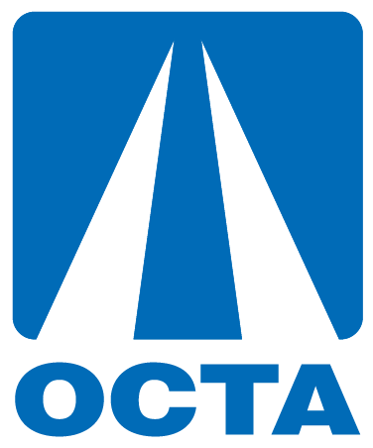
Taxpayer Oversight Committee (TOC) Recruitment
Social Media Tool Kit

Introduction
The Taxpayer Oversight Committee (TOC) is an independent 11-member committee that monitors the Orange County Transportation Authority’s (OCTA) use of revenue collected through OC GO (also known as Measure M), the county’s half-cent sales tax for transportation improvements. Members of the TOC work to ensure the transportation projects specified in OC Go are built as promised.
The Grand Jurors Association of Orange County (GJAOC) Taxpayer Oversight Committee Selection Panel is currently overseeing the recruitment program, will be screening all applications, and recommending qualified potential candidates for membership.
This social media tool kit provides copy-ready content as well as an optional graphic to promote the recruitment of the TOC. The kit provides content so that you may pick and choose text that best resonates with your constituents and post it onto any of your social media platforms. Please consider tagging @goOCTA in your social media posts so that we can easily track information sharing.
Thank you for your help in sharing OCTA’s position openings on the Taxpayer Oversight Committee.
Social Media Posts:
Twitter
Text: Become part of OC’s legacy and apply for the Orange County Transportation Authority’s (OCTA) Taxpayer Oversight Committee!
[Link: octa.net/toc]
Facebook
Text: The Orange County Transportation Authority (OCTA) invites you to apply to the OC Go (also known as Measure M) Taxpayer Oversight Committee (TOC), which has been ensuring that all OC Go funds are spent on voter-approved transportation projects for over a decade. There are openings in the First, Second, Fourth, and Fifth Supervisorial Districts. Apply today!
[Link: octa.net/toc]

Graphic:

Blog/Newsletter/Website
Text: Volunteer to Monitor Measure M (also known as OC Go) and Be Part of a Legacy
OCTA is once again seeking qualified volunteers to serve on the OC Go Taxpayer Oversight Committee (TOC). Applications are due by May 2, 2021. Interviews will be held via Zoom and conducted between May 5th – 13th with final selection taking place at the OCTA Board of Directors meeting on June 28, 2021.
The TOC is an independent 11-member committee that monitors OCTA’s use of revenue collected through OC Go, the county’s half-cent sales tax for transportation improvements. The TOC has spent more than a decade ensuring that all OC Go funds are spent on voter-approved transportation projects.
Orange County residents in the First, Second, Fourth, and Fifth Supervisorial Districts are eligible to apply.
The First District consists of the cities of Garden Grove, Santa Ana, Westminster, portions of Fountain Valley, and the unincorporated community of Midway City.
The Second District consists of the cities of Costa Mesa, Cypress, Huntington Beach, La Palma, Los Alamitos, Newport Beach, Seal Beach, Stanton, and portions of Buena Park and Fountain Valley. It also includes the unincorporated areas of Rossmoor, Sunset Beach, and Surfside.
The Fourth District consists of the cities of Anaheim, Brea, Fullerton, La Habra, Placentia, and portions of Buena Park.
The Fifth District consists of the cities of Aliso Viejo, Dana Point, Laguna Beach, Laguna Hills, Laguna Niguel, Laguna Woods, Lake Forest, Mission Viejo, Rancho Santa Margarita, San Clemente, San Juan Capistrano, portions of Irvine, and the unincorporated communities of Coto de Caza, Ladera Ranch, Las Flores, and Wagon Wheel.
Candidates must be at least 18 years of age and be willing to serve for a three-year term. Potential committee members should also demonstrate a history of participating in community activities and knowledge of transportation in their application. Elected or appointed city, district, county, state or federal officials are not eligible to serve.
The Grand Jurors Association of Orange County (GJAOC) is conducting the TOC recruitment and will recommend qualified candidates for membership. For additional information, please call 714-974-9699 or visit octa.net/TOC recruitment.

