REAOC and Hoffy Tours presents…

Pasadena Architectural Jewel

Tuesday, October 10th: 8:15 - 4:30
$75 includes picnic lunch and home & garden entries

Itinerary
- Tour the Gamble House - enjoy a private 1-hour tour of this craftsman classic, a National Historic Landmark, followed by a picnic on the grounds.

- Visit to Descanso Gardens (La Canada) - explore this highly rated botanical garden with the world's largest camellia collection.

- Bus tour of three Pasadena Historic Districts – relax, let Hoffy show you the most beautiful period-revival architecture in SoCal.
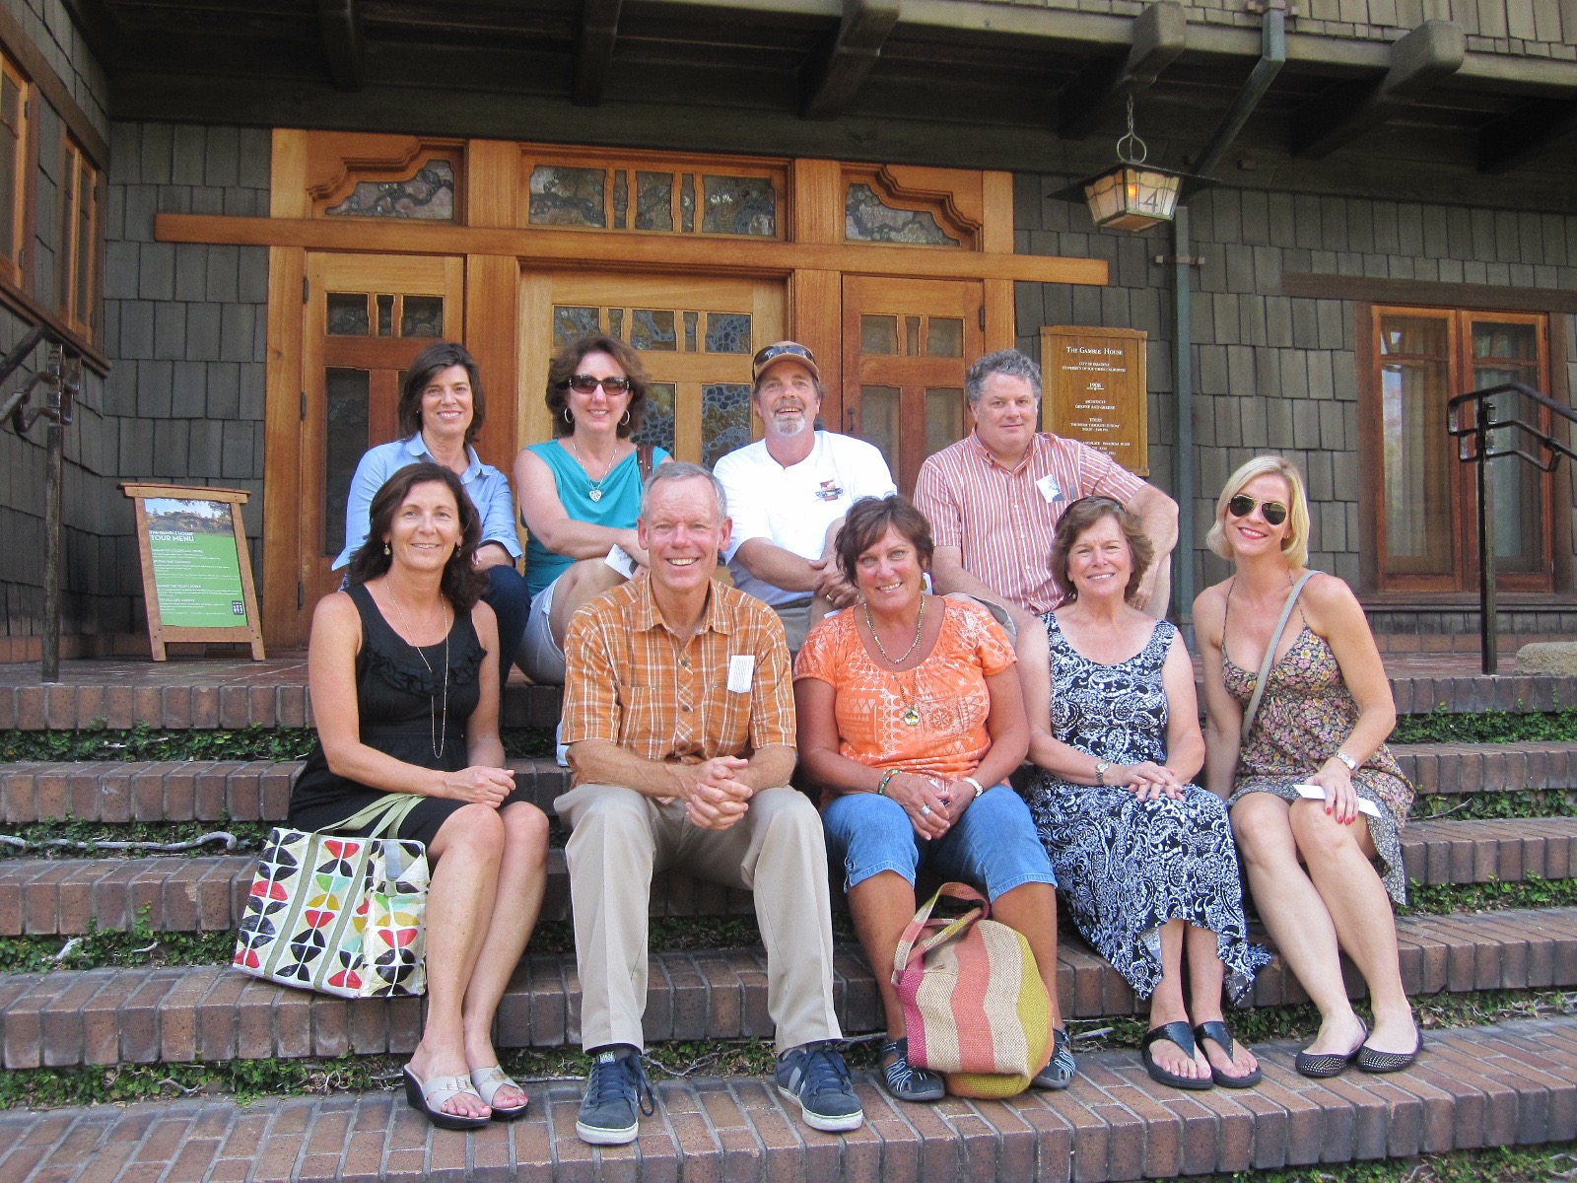
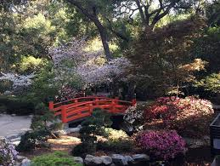
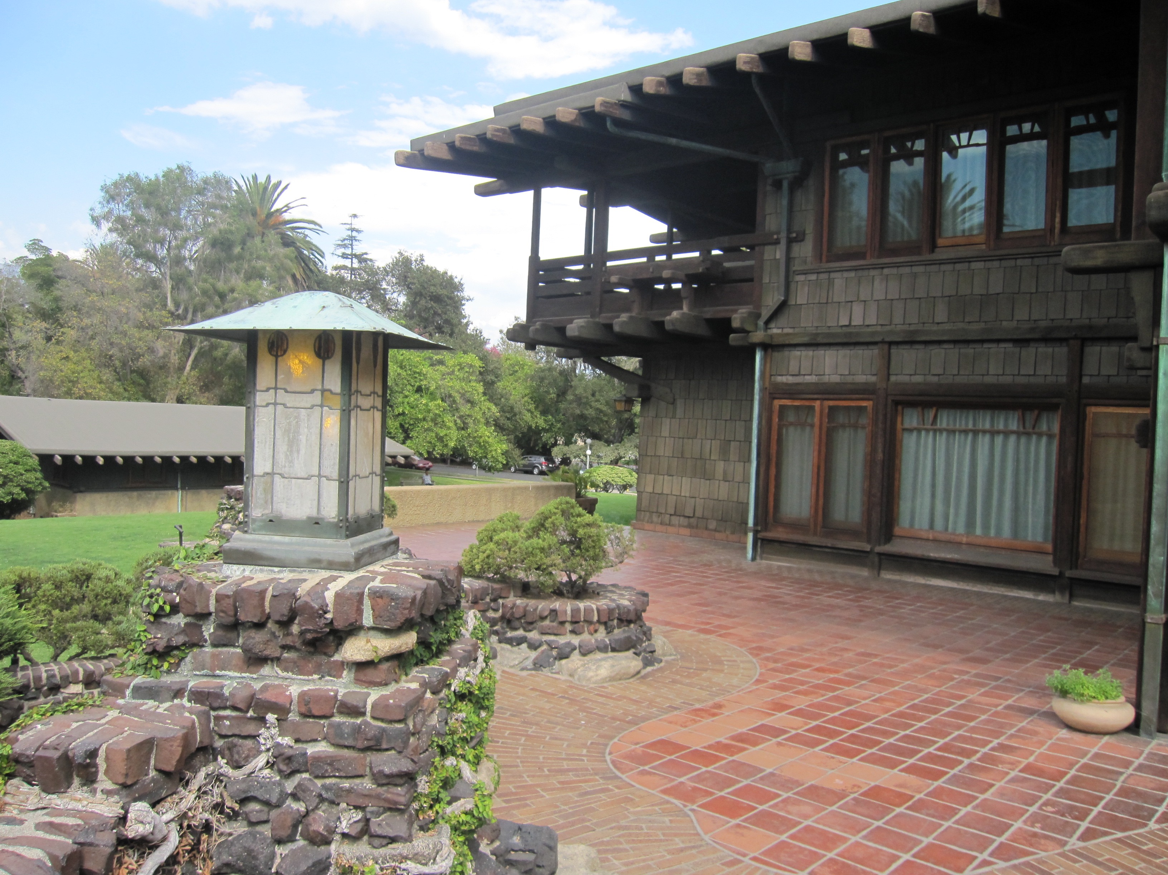
Send checks payable to REAOC:
P.O. Box 11787, Santa Ana, CA 92711

Deadline Oct 3: Members may invite friends & family
Tour departs from: OCERS 2223 Wellington Ave., Santa Ana 92711
Please arrive by 8 AM.

Easy to moderate walking required.

Snacks, water, trivia quizzes and activity fun packet provided by professional Tour Guide Bill Hoffman of Hoffy Tours, LLC
“See beautiful Pasadena in one, fun-filled day”

